HIGH POLYMER 06-12-2018

Introduction
Polymers are materials which play a vital role in our everyday life and in industries. They possess a wide range of properties from as soft as silk to as strong as steel. Because of this wide spectrum of properties of polymers, one can make a wide range of articles from simple toys to more sophisticated instruments.
Q- What are polymers and polymerization? What are types of polymerization?
High polymers are macromolecules of high molecular masses formed by covalent linkage of several small and simple chemical units called monomers. The process is known as polymerization.
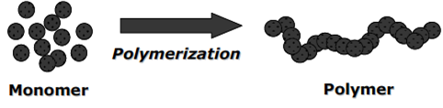
Types of polymerization: There are two types of polymerization- Addition polymerization and Condensation polymerization.
Examples: n CH₂ = CH₂ (ethylene) (addition polym) -(CH₂ – CH₂)-_{n} (polythene)

n OH-(CH₂)_{a}- OH + n HOOC-(CH₂)_{b}-COOH (cond.polym) -[O-(CH₂)_{a}-O- OC-(CH₂)_{b}-
CO]_{n}- + nH₂ bi-functional alcohol bi-functional acid Polyester

Q- Discuss (i) Bulk (ii) Solution (iii) Suspension (iv) Emulsion polymerization. Mention advantages, disadvantages and application of these.
(i) Bulk (mass) polymerization:
In the polymerization process only the monomer and the initiator are involved. Monomer is taken in the liquid state and a very small amount of initiator is dissolved in the monomer. Initiation of polymerization is effected by either heating or exposing to radiation. The reaction is kept under constant agitation for effective heat and mass transfer. Polymer product formed, is free from any contamination.
Advantages:
- Method is simple and requires simple equipment.
- Conversion is extremely high (=100%).
- Purity of the product is high.
- Product needs neither isolation nor purifications.
- The product has high optical clarity.
Disadvantages:
- The heat control is more difficult. As the reaction progresses the viscosity increases and hot spots tend to develop due to the difficulty in agitation. The uncontrolled exothermic reaction may lead to explosion.
- As the polymerization progresses, the viscosity increases, the termination becomes difficult and the rate of polymerization increases rapidly. This phenomenon of auto acceleration in polymerization rate with decrease in termination rate is called “gel effect” or auto acceleration.
- A broad molecular weight distribution in polymer occurs.
- This method is practical for relatively less exothermic polymerization reactions.
Applications: Mainly used for manufacture of plexiglass, polystyrene, PVC, polystyrenes, polyethylene etc
(ii) Solution polymerization:
In solution polymerization, like bulk polymerization, the polymerization occurs in homogeneous system. The presence of solvent facilitates the heat and mass transfer and reduces viscosity build up. The monomer, free radical initiator and chain transfer agent, if any used; are dissolved in a good inert solvent. The reaction mass is kept under constant agitation and heated to a temperature of polymerization to initiate the reaction. After the completion of the reaction, the product is isolated from the solvent by evaporation or used as such in solution form.
Advantages:
      - The viscosity build up is negligible.
      - Reaction is 100% complete
      - The heat control is easy.
      - The agitation is easy.
      - The production in solution can be directly used as adhesives and coatings.
Disadvantages:
      - The product is contaminated with solvent since the removal of the last traces of solvent is often difficult.
      - It is difficult to produce a very high molecular weight polymer since the solvent may act as a chain transfer agent, thereby limiting the molecular weight.
      - product isolation needs evaporation of solvent.
      - Requires solvent recovery and recycling.
      - Costly
Applications: This method is widely practiced for the production for the production of polyethylene, polyvinyl chloride, poly acrylonitrile and block co-polymers. The solutions of some polymers produced are directly used as adhesives, coatings and acrylic ester finishes.
(iii) Suspension polymerization:
Monomer is dispersed in an aqueous medium, suspended in the form of fine droplets which are stabilized (prevented from coagulating) in the presence of water soluble protective colloids such as surfactants (methyl cellulose, gelatin, sodium polyacrylates). Initiators used also are also soluble in monomer droplets. The reaction mixture is continuously stirred so that the reaction progresses within each droplet to form the polymer.
Monomer + Stabilizer + Initiator + (Stir well) Polymer
(in suspension (dissolved (in suspension, in globule form)
in water) in suspension)

Advantages:
      - The viscosity build up of polymer is negligible.
      - Efficient thermal control.
      - Reaction is 100% complete
      - Isolation of product is easy as it needs only filtration and washing.
      - Higher purity product.
      - The process is more economical since water is used in place of costly solvents.
      - Isolated products need no further purification.
Disadvantages:

      - The method is applicable only for polymerization of water insoluble monomers.
      - It is difficult to control particle size.
Applications:
Used for commercial production of polyvinyl chloride, polyvinyl acetate, styrene divinyl benzene (ion exchanger) etc.

(iv) Emulsion Polymerization:
Emulsions are dispersions of oil and water. The essential ingredients are monomers (water insoluble) initiators (water soluble) such as potassium per sulfate, H₂O₂ etc., and surface active agents normally referred to as surfactants Example: soaps and detergents (RCOONa, RSO₃Na). It has hydrophilic head and hydrophobic tail. At very low concentration, it gets completely dissolved in water. At a little higher concentration it gets dispersed. When the concentration of surfactant exceeds a critical micelle concentration, the soap molecules form micelles.
When the monomer is added in bulk, it remains in the aqueous phase but some of it dissolves in each of the micelle. The free radicals are generated in the aqueous phase. Radicals differ through aqueous phase, penetrate into the micelle and initiate the polymerization in each micelle.
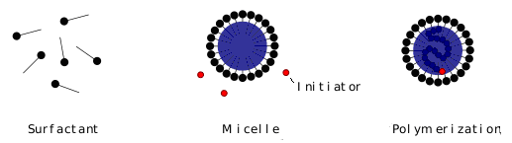

Monomer (water insoluble) + Initiator(water soluble) + Emulsifier → (stir vigorously) →
Polymer (in emulsion) → (de-emulsifier) → Polymer
Advantages:
      - Easy agitation.
      - Easy heat control.
      - Rate of polymerization is high.
      - Polymers of uniform molecular mass are obtained
      - Very high molecular weight polymer is obtained due to the continuous supply of monomers.

Disadvantages:
      - Polymer needs additional clean up and purification
      - It is difficult to remove entrapped coagulants, emulsifiers etc.
      - Method often requires rapid agitation.
Applications: This method is widely used for the manufacture of polyvinyl chloride, polyvinyl acetate and synthetic elastomers.

Q - What is glass transition temperature (T_{g})? Discuss various factors influencing the glass transition temperature.
Unlike in metal article fabrication, the polymers are not melted to the liquid form to fabricate, but heated just to its softening temperature. This is referred to as glass transition temperature.
Definition of Tg:- “The temperature at which a polymer abruptly transforms from glassy state (hard state) to a rubbery state (soft state) is called Glass Transition Temperature and denoted by Tg.”
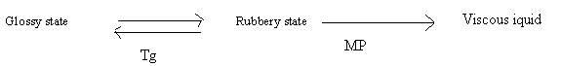
In glassy state the molecular and segmental motions are frozen and becomes hard. In rubbery state there is only segmental mobility, molecular mobility forbidden. On further heating much above T_{g} both segmental and molecular mobility arises and polymer behaves like viscous liquid, it is melting point of polymer (MP).

Determination of glass transition temperature
Glass transition temperature can be determined by studying variation in Young’s modulus (Fig. a) and change in volume at different temperature (Fig. b).

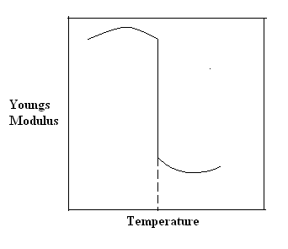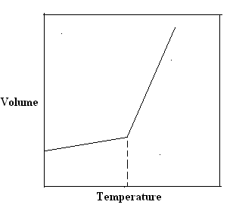
(a) (b)

Fig.1. Variation in properties of a polymer at glass transition temperature (a) Young’s
modulus (b) Volume.

Fig. 1(a) shows the sudden drop in Young’s modulus at Tg and Fig. 1(b) shows the abrupt change in volume at Tg.

Factor influencing the glass transition temperature.
1. Flexibility: A free rotation motion of the polymer chain imparts flexibility to the polymer. Linear polymer chains made of C-C, C-O and C-N single bonds have a higher degree of freedom of rotation and low Tg, example polyethylene. Presence of inherently rigid structures in the polymer chains such as aromatic or cyclic structure or bulky side groups on the backbone of C atoms hinder the freedom of rotation thus lowering the chains flexibility and increase in Tg. Example: Polysterene
Ex; T_{g} of polyethylene is -110 ⁰C
T_{g} of polystyrene is 100 ⁰C

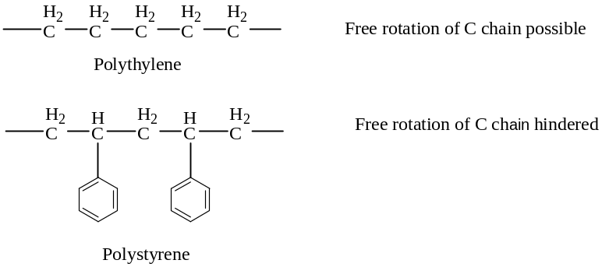
2. Intermolecular forces: Presence of large number of polar groups in the molecular chains leads to strong intermolecular cohesive forces which restricts the molecular mobility, this leads to an increase in T_{g}. For example: T_{g} of polyprolene (no polar groups) is -18 ⁰C, where as T_{g} of Nylon 6, 6 (contains polyamide polar group) is 57 ⁰C
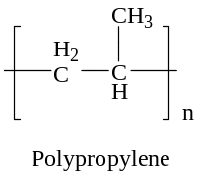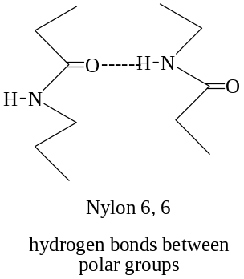
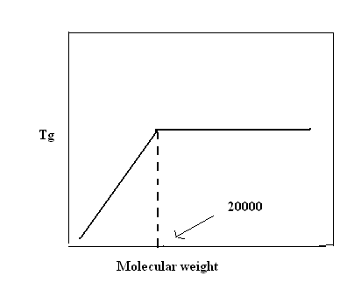
Hydrogen bond, covalent bond and vander waals forces of attraction between polymer chain increases T_{g} value.
3. Molecular Weight: higher the molecular mass more is the restriction of the molecular freedom and also bulkiness also increases and thereby T_{g} increases. However, T_{g} is not significantly affected by the molecular mass if the degree of polymerization above 250 or molecular mass is above 20000.
4. Branching and cross linking: A small amount of branching will tend to lower T_{g}. Increase in chain ends in branched chain polymer increase the free volume thus decreasing the T_{g} . On the other hand, a high density of branching brings the polymer chain closer, lowers the free volume thus reducing the chain mobility and resulting in an increase in T_{g}. Cross linkings like hydrogen bond, covalent bond and vander waals forces of attraction between polymer chains restricts molecular motion and thereby increases the T_{g} value.
Q What are the significances of T_{g}?
Many polymers show an abrupt change in their physical properties at their glass transition temperature
      - Different fabrication works like moulding, shaping, calendaring etc., can be carried out with knowledge of , as the entire machinery can be pre-set to that temperature.
      - It is an important property of polymer that measures flexibility of polymer molecule, and its response to mechanical stress.
      - Tg value gives information regarding the polymer used temperature which could be used either as rubber or as plastic.
      - MP value (Temperature of melting) along with Tg gives a valuable information of the temperature region at which polymeric material gets changed from rigid solid state to soft viscous state that helps in processing temperature of the polymer.

Q- Discuss structure and property relationship in polymers

The fundamental properties of polymers which are directly related to their structural characteristics are (a) Crystallinity (b) Strength (c) Elastic nature (Elasticity) and
(d) Chemical Resistance

(a) Crystallinity: the degree, to which molecules of a polymer are arranged in orderly pattern with respect to each other, is a measure of crystalinity. It is due to denser packing of molecular chains. Linear polymers are more crystalline than branched polymers and stiffness of linear polymer is also more.
Every polymer contains both crystalline nature and amorphous nature. The degree of crystallinity depends on how best the polymer chains are orderly and closely packed. The polymers having high degree of crystallinity exhibit high tensile strength, impact resistance and posses high density with sharp melting point (MP) and solubility of polymer decreases with increase in crystallinity.
Crystallinity in polymer depends on the following characteristics: i) Degree of symmetry: Polymers with long repeating units with low degree of symmetry do not crystallize. For example, PVC and PMMA are amorphous. ii) Intermolecular forces: Polar interactions such as hydrogen bonding and Van der waals forces keep the molecular layers in an orderly pattern and increase crystallinity. iii) Degree of cross linkages: A high degree of cross linkages in the molecular layers through covalent bonding and without bulky side chains gives higher crystallinity.

(b) Strength: The strength of a polymer includes its ability to bear the mechanical load, tensile strength and impact strength. This depends on the following structural characteristics:
(i) Molecular mass: Generally, polymers of low molecular mass are soft while those of high molecular mass are strong and hard. However every polymer has a threshold molecular mass value below which it does not possess useful strength and above which it has little effect on strength.
(ii) Cohesive forces: If the molecular chains are held together by inter - molecular forces of attraction like hydrogen bonding and van der wals forces there will be increase in strength of the polymer. (iii) Cross linkages : Large degree of cross linkages among the molecular chains by strong covalent bonds result in giant three dimensional solid structure and hence increase strength of the polymer. (iv) Slipping power: If the polymer molecules are simple in structure as in polythene the slipping power of one molecular layer over the other will be more and hence reduce strength. On the other hand if the molecular chain contains large humps due to atoms like chlorine as in PVC the movement of the molecular chains will be restricted and hence increase strength of the polymer.
For example- the strength of polyethylene (straight chain molecule) is less compare to polystyrene, because of bulky group in polystyrene restrict the free movement of chains.

c) Elasticity: Elastic character is the ability of the polymer to recover the original shape and size when the deformation force is removed. The elastic nature in polymer is attributed to mainly:
(i) Presence of Coiled and entangle snarls in the molecular chains gives elastic nature. In unstressed condition these snarls are in random arrangement leading to amorphous state of polymer. On stretching the chain, orientation causes crystallization making the polymer stiff and remains in that state as long as it is stressed. (ii) High degree of crystallinity and cross linkages at suitable molecular positions in the polymer chains increase elastic nature.
d) Chemical resistance: Chemical attack on polymers causes swelling, softening and loss of strength of material. The resistance of chemical attack of a polymer depends on several factors:
(i) non-existence of polar groups in the molecular chains increase the resistance to polar chemicals and solvents . Polymer chains with polar groups like - COOH, -OH , -NH₂ etc., are affected by polar chemicals and solvents.
(ii) High degree of crystallinity decrease the penetrating power of chemicals and solvents into the polymer causing resistance to them.
(iii) Grater the degree of cross-linking in the polymer, lesser is its solubility.
(iv)For a given polymer, the solubility or swelling character decreases with increase in the molecular weight of the polymer.

Q- What is the number-average molecular mass and weight-average molecular weight of
a polymer?
Molecular Weight of Polymers

Polymer molecules are formed by the union of several small repeating units called monomers. Degree of Polymerization: The number of repeating monomer molecules to make a polymer molecule is called the ’ degree of polymerization’.
Polymerisation
For example: xCH₂ = CH₂ -[ CH₂-CH₂₋- ]_{x}
(Ethylene) ( Polythene )
where, ‘ n ‘ denotes the degree of polymerization. The molecular mass of ethylene, Mº= 28, If, x = l000, the molecular mass of the polymer molecule,
M = ‘x ‘ x Mº = 1000 x 28 =28000.
However, a polymer consists of a mixture of several molecules of varying chain lengths due to the difference in their degree of polymerization ‘x’ and hence vary in their molecular mass. Therefore, polymer is considered to have an average molecular mass. Two different batches of the same polymer may have different average molecular mass.
There are two types of average molecular mass recognized. They are: (i) Number Average Molecular Mass (ii) Weight Average Molecular Mass.
(i) The number-average molecular mass (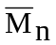): It is defined as “ the ratio of total mass of all the molecules in a polymer sample to the total number of molecules present”.
If there are n₁, n₂, n₃ ………..n_{i} number of molecules of masses M₁ , M₂ , M₃ ……. M_{i} respectively then the total mass of the polymer sample will be n₁M₁ + n₂M₂ + n₃M₃ …………+ ni Mi and total number of molecules will be n₁ + n₂ + n₃ ......+ n_{i} . Hence,
The number-average molecular massof polymer is given by

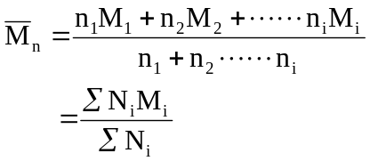
The number average molecular mass is a good index of physical properties such as impact strength and tensile strength ,but not an index of flow of polymer fluid.
The number average molecular mass is determined by the measurement of their colligative properties such as depression of freezing point, elevation of boiling point and osmotic pressure.
(ii)The weight-average molecular weight (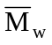):It is defined as “ the ratio of the sum total of the product of weight fraction and the molecular mass of all the molecules to the total weight fraction of the polymer sample”.
If w₁, w₂, w₃……….w_{i} are the weight fractions of molecules whose molecular masses are M₁, M₂, M₃ ………M_{i} respectively, then the total weight of the polymer will be w₁M₁ + w₂M₂ + w₃M₃ …….+ w_{i} M_{i} and its total weight fraction will be, w₁ + w₂ + w₃ ……….+ w_{i} , Hence,
Average molecular Mass, Mw =( w₁ M₁ + w₂ M₂ + w₃M₃ ….. +w_{i} M_{i} )/ (w₁ + w₂ + …….+ w_{i} )
But, since the weight fraction of a molecule, w = n M , it may be represented by substituting ‘w’ by nM as :
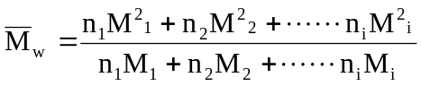
The weight average molecular mass Mw, of a polymer is , either equal to or greater than its Mn. This deviation is a measure of poly - dispersity of the polymer. The system in which all polymer molecules have identical molecular mass, will have Mw = Mn or Mw / Mn = 1
The weight average molecular mass contributes to the measured results relative to its size. This molecular mass is determined by light scattering method, ultra centrifuge method and sedimentation- equilibrium methods.

Q What are conducting Polymers? How are they synthesized? Explain the conduction
mechanism in polymer.
Most of the polymers are insulators, with desirable properties such as light weight, processabllity, durability, and low cost. By designing the molecular structures of polymers, chemists have developed new materials that exhibit electrical conductivities comparable to metals while retaining the advantages of polymers. Generally, these electrically conducting polymers are composed of conjugated polymer chains with л-electrons delocalized along the backbone. The polymers are converted to the electrically conductive, or doped, form via oxidation or reduction reactions that create delocalized charge carriers. Charge balance is accomplished by incorporating an oppositely charged counter ion into the polymer matrix.
An organic polymer with highly delocalized pi-electron system, having electrical conductance of the order of a conductor is called a conducting polymer.
Synthesis:
An organic polymer can be converted into a conducting polymer if it has
 Linear structure
 Extensive conjugation in polymeric back bone (pi-back bone)
The conducting polymers are synthesized by doping, in which charged species are introduced in organic polymers having pi-back bone. The important doping reactions are:
- Oxidative doping (p-doping)
- Reduction doping (n-doping)
- Protonic acid doping (p-doping)
- Normally electron in a polymer are localized and do not take part in conducting but doping can create delocalized electrons and responsible for conduction.

Mechanism of conduction:
Band theory of solids has been used to explain the conduction mechanism in conducting polymers. The neutral polymer (insulator) be transferred into a conductor by doping with electron donar (reducing dopant such as sodium naphthalide) or an electron acceptor (like iodine vapor, FeCl₃, iodine in CCl₄, HBF₄, perchloric acid and benoquinone)
The removal of an electron form the polymer pi-back bone using a suitable oxidizing agent leads to the formation of delocalized radical ion called polaron.
A second oxidation of a chain containing polaron, followed by radical recombination yields two charge carriers on each chain. The positive charge sites on the polymer chains are compensated by anions (I₃⁻ ) formed by the oxidizing agent during doping.
The delocalized positive charges on the polymer chain are mobile, not the dopant anions. Thus, these delocalized positive charges are current carries for conduction. These charges must move from chain to chain as well as along the chain for bulk conduction. On doping polyacetylene using iodine in CCl₄, for partial oxidation, the conductivity increases from 10⁻⁵ S. cm⁻¹ to 10³-10⁵ S.cm⁻¹.

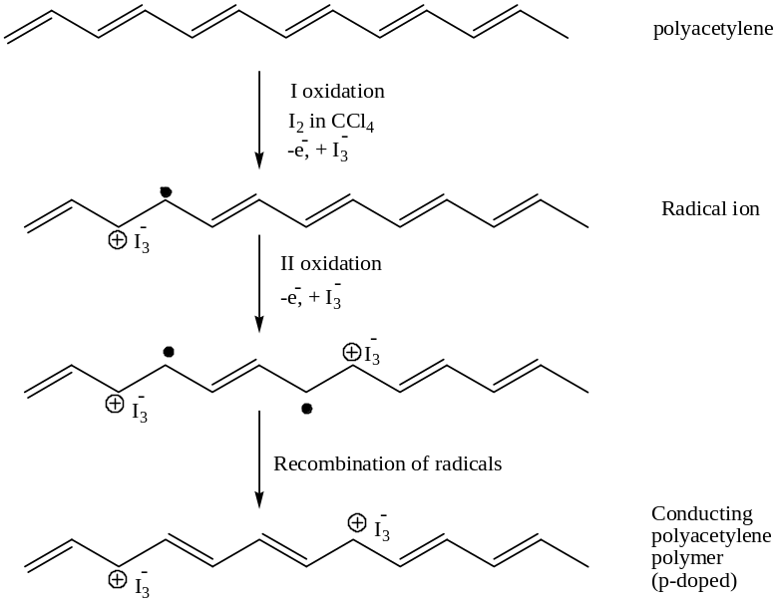

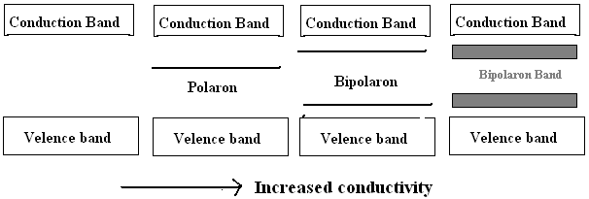

Applications
Conducting polymers are highly promising materials to be used in electric and electronic applications. Some of the applications are:
- as electrode material for commercial rechargeable batteries, for higher power to weight ratio (coin type batteries)
- as conductive tracks on printed circuit boards
- as sensors-humidity sensor, gas sensor, radiation sensor, biosensor for glucose, galactose, etc.
- in electronic display windows.
- In information devices.
- As film membranes for gas separations.
- In fuel cells as the electro catalytic materials.
Q Discuss synthesis, properties and applications of (i) Teflon (ii) PMMA
(i) Teflon: Teflon is the trade name for polytetra fluoroethylene (PTFE).
- Monomer used: Tetra fluoroethylene (TFE) (CF₂ = CF₂)
- Type of polymerization: Emulsion polymerization
- Temperature: 730ºC
- Pressure - 1000 PSI
- Initiator: H₂O₂ or ammonium persulphate
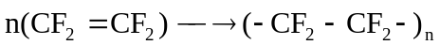
Properties:
      - PTEE is linear, higher crystalline solid and its softening temperature is 330ºC.
      - It is highly resistant to chemicals and is very good insulator.
      - High density (2.30 g/cm³)
      - High resistance to corrosive chemicals like oxidizing and reducing agents and strong mineral acids including fuming nitric acid.
      - Not wetted by either oil or water.
      - Remains slippery over a wide range of temperature (40 to 300⁰C).
      - Low coefficient of friction.
      - High thermal stability, good mechanical strength.
      - Excellent electrical insulating properties.
Applications:
- For insulation in motors, transformers coils and capacitors
- In the manufacture of belts, gaskets, tank linings…etc
- Antistick applications: Teflon is not wetted by water or oil. Teflon coated articles are used for non-sticking kitchen wares.
- As anti- corrosive coating

(ii) Polymethylmethacrylate (PMMA) or (Plexi glass):
- Monomer used – methylmethacrylate (CH₂ = CCH₃COOCH₃)
- Type of polymerization – Addition polymerization (Emulsion)
- Initiator – Hydrogen peroxide or acetyl peroxide
- Temperature - 60-70 º C under atmospheric pressure
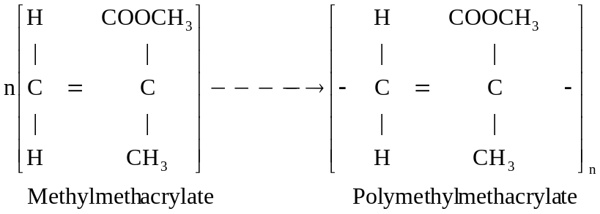
Properties:
- Highly transparent thermoplastic softening at 120 ºC.
- Excellent optical properties and it is an excellent substitute for glass.
- Not affected by sunlight but affected by many chemicals and some organic solvents
- Has good dimensional stability.
Applications:
(a) PMMA is used for making lenses, wind screens, T.V. screens etc.
(b) It is used in emulsions, paints and adhesives.
(c) Plexi glass used in the manufacture of domestic appliances and chemical equipment.

Q. What are Biopolymers (Biodegradable) Polymers? Mention Advantages and disadvantages
Introduction
Biopolymers are biodegradable chemical compounds and they are considered as the most organic compound in the ecosphere. The name “Biopolymer” indicates that it is a bio-degradable polymer. Biopolymers are polymers produced by living organisms. In other words, they are polymeric biomolecules. Since they are polymers, they contain monomeric units that are covalently bonded to form larger structures. Cellulose is the most common organic compound and biopolymer on Earth. About 33 percent of all plant matter is cellulose. The cellulose content of cotton is 90 percent, for wood it is 50 percent.
Definition
‘Biopolymers are macromolecules of living organisms that is formed by linking together several smaller molecules is called as a biopolymer’. Example, formation of a protein biopolymer from amino acids, formation of DNA molecule from nucleotides.
Some Biopolymer examples are: Proteins, Carbohydrates, DNA, RNA, Lipids, Nucleic acids, Peptides, Polysaccharides, lignin, etc
Advantages biopolymers:
The polymers play an essential role in nature, some of the advantages of biopolymers are as follows:
- These polymers can reduce carbon dioxide levels in the atmosphere and also decrease carbon emissions. This happens because bio-degradation of these chemical compounds can release carbon dioxide that can be reabsorbed by crops grown as a substitute in their place.
- Biopolymers reduce dependency on non-renewable fossil fuels. These are easily biodegradable and can decrease air pollution. It greatly reduces the harmful effect of plastic use on the environment. Long term use of biopolymer use will limit the use of fossil fuel.
- They are extremely useful in performing functions like storage of energy, preservation and transmittance of genetic information and cellular construction.
- Sugar based polymers, such as polysaccharides, naturally degenerate in the human body without producing any harmful side effects. This is the reason why they are used for medical purposes. Polysaccharides are commonly used as surgical implants.
- Starch based biopolymers can be used for creating conventional plastic by
extruding and injection molding.
- Cellulose based Biopolymers, such as cellophane, are used as a packaging material. These chemical compounds have several advantages such as: can be used to make thin wrapping films, food trays and pellets for sending fragile goods by shipping.
- Biopolymers are carbon neutral and can always be renewed. These are sustainable as they are composed of living materials.
Q. What are Polymer composites? Explain their properties and uses

A polymer composite is a physical mixture of two or more materials of distinct phases with a recognizable inter -phase. The properties of composites are the combination of all the unique properties of each of the components and phases, without losing any of the desirable properties of the same. In addition, it has its own mechanical, electrical and chemical properties.
Any composite is composed of two components 1. Matrix 2. Reinforcing fibrous material.
The matrix is normally an epoxy resin or a polyamide which holds the fibres together. It may be fibre of glass or carbon or Kevlar.
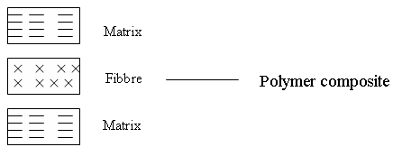

Need to develop composite materials:
When more than one material is used in combination it is found to provide better characteristics, made to order for the user. They have their own mechanical, electrical and chemical properties, Compared to traditional materials, composites have greater strength per unit weight. Thus there is material, energy and cost saving.

Advantages of Composite materials:
There are many advantages of composites compared to the traditional materials. They are: 1. Light in weight 2. Have high strength to weight ratio 3. Stronger than conventional materials like steel and aluminium 4. Have good corrosion resistance even at high temperature 5. They have high fatigue strength.
Application:
- Glass fibre reinforced polymer composites are used in automotive products, aircraft components, pressure bottles, storage tanks, boats, printed wiring boards and sporting goods.
- Boron fiber reinforced composites with high stiffness and compression properties are used in aircraft applications for wings and horizontal and vertical stabilizers. They have also found applications in the sporting goods area, being used on tennis rackets, squash rackets and fishing rods.
- Graphite fiber reinforced composites are used in aircraft wings, spacecraft, missiles, sports rackets, agriculture, medical devices, weaving machines, etc.
- Aramid fiber reinforced composites are used for filament winding of pressure vessels, aerospace applications, protective clothing and automotive applications
Q - Synthesis and applications of carbon fiber
Carbon fibre is a polymer which is a form of graphite with carbon ring structure. The graphite sheets are thin and form long ribbons. Bunches of these ribbons pack together to form fibers.
Synthesis: Carbon fiber is made by heating polyacrylonitrile a polymer containing CN groups carefully and slowly when the polymer cyclises through the cyano groups to form a polycyclic chain. The resulting solid is heated gradually so that hydrogen is expelled and rings become aromatic. Then it is slowly roasted at 400-600ºC when an adjacent chain join together losing more hydrogen gas. Then the temperature is gradually raised to 2000ºC to get wider ribbon like mass. The temperature is maintained around 2000ºC till all the nitrogen is expelled leaving behind wider ribbon like pure carbon fiber in the graphite form.
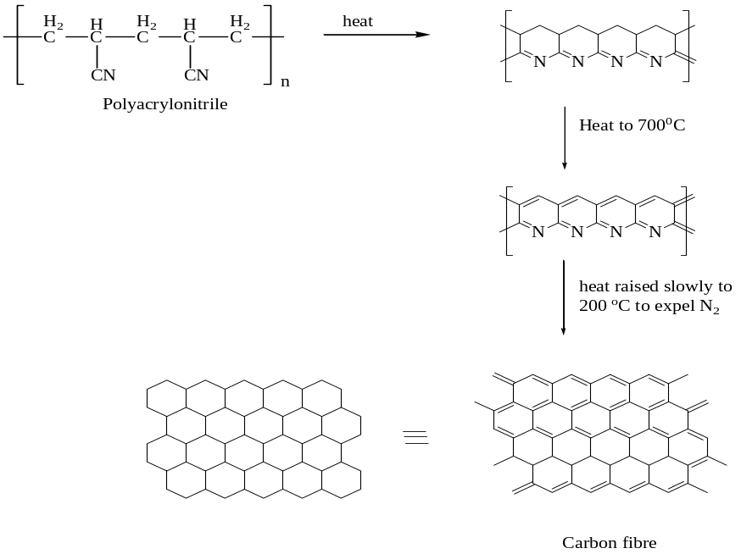

Properties: 1. Carbon fibers can have up to three times the stiffness and fifteen times the strength of steel, but very much lighter in weight.
2. Graphite structure is made of densely packed hexagonal layers which results in highly anisotropic mechanical and thermal properties.
Applications: 1. Used for making aircraft wings
2. In space craft and missiles
3. Making of sports rackets
4. In the manufacture of medical instruments
5. Making of weaving machines

Question Bank:
- What is polymerization? Explain solution and suspension polymerization technique
- Explain mass and emulsion polymerization techniques.
- Give the synthesis, properties and applications of:
(i) Teflon (ii) PMMA
- What is glass transition temperature? Mention its significance, Explain any two factors that affect the glass transition temperature of a polymer.
- How the structure of a polymer influences the following properties
(i) Strength (ii) Crystallinity (iii) Elastic nature (iv) Chemical resistance
- What is the number-average molecular mass and weight-average molecular weight of a
polymer?
- What are polymer composites? Mention their applications. Explain synthesis and
applications of crbon fiber.
What are Biopolymers Biodegradable Polymers, Mention Advantages and disadvantages
- What are conducting polymers? Explain the mechanism of conduction in polyacetylene.
- A polymer sample contains 1,2,3 and 4 molecules having molecular weight 1x 10⁵, 2x 10⁵ , 3X 10⁵ and 4x 10⁵ respectively. Calculate number average and weight average molecular weight of the polymer.
Solution
Here, n₁ =1 , n₂= 2, n₃ =3 and n₄ = 4, M₁ =1 x10⁵, M₂ =2 x 10⁵, M₃ =3 x 10⁵ and M₄ = 4 x 10⁴ hence,
Mn = ( n₁ M₁ + n₂M₂ + n₃M₃+ n₄M₄) / (n₁+ n₂+ n₃ + n₄)
= [ 1( 1x 10⁵⁾ +2( 2x10⁵) + 3( 3x10⁵ ) + 4 ( 4x 10⁵ ) ] / [ 1 + 2 + 3 +4 ]
= [ (1 + 4 + 9 + 16) 10⁵ ) / 10 =3.0 x 10⁵
Mw = (n₁M₁² + n₂M₂² +n₃M₃² +n₄ M₄²) / ( n₁M₁+ n₂M₂ + n₃M₃ +n₄ M₄)
=[ 1 (1x10⁵)² + 2 (2 x 10⁵)² +3 (3 x10⁵ )² + 4 (4 x10⁵)²] / [ 1(1x 10⁵) + 2 (2x10⁵)+ 3 (3x10⁵) + 4( 4x10⁵)
=( 1+ 8 +27 + 64 ) x10¹⁰ / ( 1 + 4 +9 + 16) x 10⁵
= 3.3 x 10⁵
- Poly-propylene polymer is found to have the following composition -[CH₂-CH (CH₃)-]_{x} x values are 400, 500 and 600 and they are 20, 30 and 50 in numbers respectively. Calculate Mn and Mw.

Solution:
Mass of each propylene unit = 42,
Hence, M₁ = 42 x 400 =16800, M₂ = 42 x 500 =21000, M₃ = 42 x 600 =25200

M_{n} = n₁ M₁ + n₂ M₂ + n₃ M₃ / n₁ + n₂ + n
= 20 x 16800 + 30 x 21000 + 50 x 25200 / 20 + 30 + 50 = 22000

Mw = n₁ M₁² +n₂ M₂² + n₃ M₃² / n₁M₁ + n₂M₂ + n₃ M₃
= 20 x (16800)² + 30 x (21000)² + 50 x (25200)² = 22715

- If we have a mixture having 5 molecules of mol.wt 3 x 10³ , 3 molecules of mol. wt 4 x 10³ and 2 molecules of mol. wt 2 x 10³. Calculate Mn and Mw.
Solution:

Mn = n₁M₁ + n₂ M₂ + n₃ M₃ / n₁ + n₂ + n₃
= 5 x (3 x 10³) + 3 x ( 4 x 10³) + 2 x ( 2 x 10³) / 5 +3 +2 = 3.1 x 10³

Mw = n₁ M₁² + n₂ M₂² + n₃M₃² / n₁M₁ + n₂ M₂ + n₃ M₃
= 5 x (3 x 10³)² + 3 x ( 4 x 10³)² + 2 x ( 2 x 10³)² / 5 x 3 x 10³ + 3 x 4 x 10³ + 2 x 2 x10³
= 45 x 10⁶ + 48 x 10⁶ + 8 x 10⁶ / (15 + 12 + 4) x 10³
= 101 x 10⁶ / 31 x 10³ = 3.258 x 10³

- Size exclusion chromatographic data of a new polymer shows the following molecular weight distribution.
Number of Molecules | 5 | 3 | 2
Mass of each molecule | 10,000 | 30,000 | 60,000
Calculate the number average (Mn) and the weight average (Mw) molecular weights of the
polymer.

